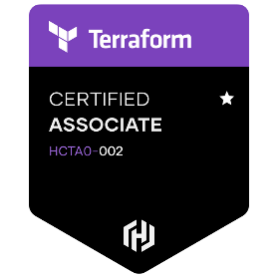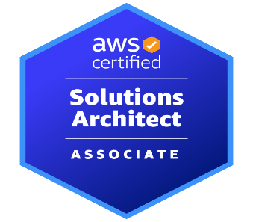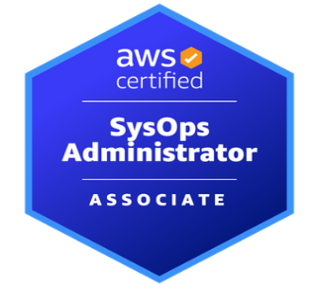

**SANDEEP CHINTA**

**AWS Engineer**

**Phone:682-716-1119, Email:Sandeep.chinta0102@gmail.com**

**IT professional** with **10+** years of **Information Technology** industry experience with ability to

accomplish all aspects of the software configuration management **(SCM) process,** systems deployment engineering (**SDE), AWS and** **DevOps in CI/CD pipeline, Build/Release management and Systems Engineering**.

**Professional**

**Summary:**

* Extensive experience in **Centos/RHEL/Unix** System Administration, System Builds, Migrations, Server Builds, Installations, Upgrades, Patches, Migration, Troubleshooting.
* Designing and developing new back-end services, maintaining, and expanding AWS infrastructure.
* Good Experience in Build and Release Management, Continuous Integration/Continuous Delivery and Configuration Management.
* Migrated applications from DXC and other public clouds to AWS.
* Experience in implementing AWS Well Architected Framework
* Experience in Server infrastructure deployment on AWS Cloud, extensive usage of **Virtual Private Cloud (VPC), CloudFormation, CloudFront, EC2, RDS, S3, Route53, SNS, SQS, Redshift, EBS and Cloud Trail**.
* Experience on Application Deployments & Environment configuration using **Ansible.**
* Experience in writing **Cloud Formation Scripts** to automate resource provisioning.
* Experienced in Troubleshooting AWS related Network issues.
* Experienced in AWS Security technologies such as IAM, **Guard Duty, Inspector, System and patch manager** etc.
* Designed and Implemented CI/ CD Pipelines and MLOps Pipelines through Code Pipeline, Code Build, Code Deploy, Gitlab.
* Implemented Sage maker as a Platform for Data Scientists to work on.
* Experienced in automation of setting up highly available applications through ECS Cluster by making use of Docker Images pushed to ECR Repos.
* NAFTA Response Lead.
* Experiences on Setup and build **AWS** infrastructure various resources **VPC, EC2, S3, EBS, Security Group, Auto Scaling**, **RDS etc.,** in **Cloud Formation** **JSON/YAML** templates.
* Experienced in providing 24*7 support to development teams based out of AWS.
* Utilized **Kubernetes** for the runtime environment of the CI/CD system to build, test deploy.
* Implemented a Continuous Delivery pipeline with Docker, and GitHub and AWS
* Configuring and updating JSON files to create new stacks for Deployment using **Docker Marathon**.
* Implemented rapid-provisioning and **life-cycle management** for Centos/RedHat using **AmazonEC2, Chef, and custom Ruby/Bash scripts.**
* Proficient in Writing scripts to automate simple tasks (**Python, Yaml, Bash** etc.)

**Professional Experience:**

**AWS Cloud Engineer**

**Magellan Health, Frisco, Texas, USA Sep 2019 – Present**

**Responsibilities:**

* Automated AMI Update process using SNS, System Manager, Rules, Event Bridge Schurles, Auto Scaling Groups, Lambda.
* Using Veracode tool to generate Vulnerability report stored in S3 bucket. Whenever new code checked-in and Monthly Scan reports generated using Code Build, Code Pipeline, S3, Event Schurles. Automated AMI Update process using SNS, System Manager, Event Bridge Rules, Event Bridge Schurles, Auto Scaling Groups, Lambda.
* Using Veracode tool to generate Vulnerability report stored in S3 bucket. Whenever Event Bridge new code checked-in and Monthly Scan reports generated using Code Build, Code Pipeline, S3, Event Schurles.
* Worked on blue & green deployment in AWS ECS.
* Create and maintain highly scalable and fault tolerant multi-tier AWS environments using CloudFormation and Terraform.
* Actively participated in the Design of Multi Account Landing Zone.
* Developed an infrastructure as a code using Terraform while applying a fully modularized approach.
* Managing of the resources in EC2, S3, EBS, VPC, ELB, CloudFront, CloudFormation, RDS, Elastic beanstalk, CloudWatch, Ops Work, Data Pipeline, Route53, Redshift, Glacier, SES and IAM.
* Responsible for setting up dashboards in CloudWatch to get OS level metrics and setting monitoring to alert on resources availability.
* Documenting run books to enable effective operational support activities when incident and problem management activities occurred.
* Evolve and maintain key enabling technologies to support the business needs to integrate processes, information flows and applications to ensure alignment across the enterprise to sustain operations.
* Automate tasks using Lambda, Python and BOTO3 for Cost Optimization.

**DevOps Engineer**

**LOYALTY-METHODS Jan 2017 – Aug 2019**

**Responsibilities:**

* Experienced in setting up High Available Architecture Application using Auto Scaling Groups.
* Experienced in troubleshooting ECS Services issues.
* Experienced in handling operations and maintenance of infrastructure in AWS.
* Experienced in writing python codes to automate operational activities like rotating AWS Access Keys, terminating unused resources, stopping unused resources etc.
* Experienced in writing CloudFormation scripts to deploy resources using json/yaml code.
* Experienced in deploying Applications in Blue/Green deployments.
* Experienced in building resources like docker images, aws infra through Jenkins pipelines.
* Experienced in GitHub.
* Experienced in Linux Administration.

**Linux Admin**

**Southern Online Bio Tech Ltd.  India                                                                        May 2011- Dec 2014**

Li

**Responsibilities:**

* Experienced setting up the architecture of the system and performs routine system maintenance.
* Performs system maintenance by reviewing error logs and report the error.
* Ensuring efficiency and smooth workflow of Linux operating systems
* Installing and conducting regular maintenance checks
* Troubleshoot, perform repairs, and monitor systems performance to ensure optimal operations.
* Create system backup.
* provided technical support.
* Maintained System security by identifying vulnerable areas and provided protection.
* Maintained best practices on managing systems and services across all environments.

**Certifications:**

* **AWS Certified Solutions Architect Associate.**
* **AWS Certified SysOps Administrator Associate.**
* **HashiCorp Certified Terraform Associate.**

**Education**

**Master’s Silicon Valley University, San Jose CA, USA.**

**Bachelors JNTUK, AP, INDIA.**